

**PROJECT**

**MRT TICKETING**

Created by:

1. FAUZAN NUGROHO
2. KI AGUS MUHAMMAD NIZAR RAMADHAN

3. MUHAMMAD NUR ISRSYAD

Faculty : MUHAMMAD RIZA IQBAL LATIEF

Semester : 2

Quarter : 4

Class : 2NAP1

**CONTINUING EDUCATION PROGRAM CENTER**

**FOR COMPUTING AND INFORMATION**

**TECHNOLOGY FACULTY OF ENGINEERING**

**UNIVERSITY OF INDONESIA**

**2019**

# PROJECT ON

**Created by**

Group : 7

Name :

1. FAUZAN NUGROHO
2. KI AGUS MUHAMMAD NIZAR RAMADAN
3. MUHAMMAD NUR IRSYAD

**NIIT**

# PROJECT ON

***MRT TICKETING***

# BOOKSTORE

Batch Code : 2NAP1

Start Date : 16 May End Date: 29 May

Name of the Coordinator : MUHAMMAD RIZA IQBAL LATIEF

Name of Developer :

1. FAUZAN NUGROHO
2. K AGUS MUHAMMAD NIZAR R
3. M NUR IRSYAD

Date of Submission : 29 May

**MRT TICKETING**

# CERTIFICATE

# CERTIFICATE

This is to certify that this report, titled “**MRT TICKETING”** embodies the original work done by **FAUZAN NUGROHO, KM NIZAR RAMADAHAN** and **M NUR IRSYAD** in partial fulfillment of their course requirement at NIIT.

Coordinator: MUHAMMAD RIZA IQBAL LATIEF

**NIIT**

# ACKNOWLEDGEMENT

Writer have benefited a lot from the feedback and suggestions given to us by Mr. Muhammad Riza Iqbal Latief and other faculty members. Writer make this project to fulfill our assignment. Writer said Alhamdulillah to Allah S.W.T because of his blessing, writer can complete this project. Writer know this paper is far from perfection. Writer hope if writer friend and writer faculty give any comment and suggestion to make this paper better than before.

Writer also said thank you to:

1. Our Family who give many support to make this paper completed.
2. Mr. Muhammad Riza Iqbal Latief as the guide’s lecturer that give put together with the suggestion, idea, and constructive spirit to make this project better.
3. Our Friends who give many idea, spirit and comment to our project.

If the writer made a mistake in writing the application of this MRT TICKETINGWriter ask forgive to all reader and listener of this paper.

Depok, 29 May 2019

Author

# ACKNOWLEDGEMENT

# SYSTEM ANALYSIS

**System Summary:**

This application use windows form with C# language called “MRT TICKETING”. This application helps on buying MRT tickets.

# SYSTEM ANALYSIS

**There are 6 class:**

1. Login
2. Top up
3. Booking
4. Profile
5. History

Following explanation about the class above:

* + - 1. **Class Login and Register**

This class contains syntax for login the application and input the username and password.

* + - 1. **Class Top up**

This class contains syntax for displaying intros such as choosing insert data or view data, view the schedule of court and exit the application .

* + - 1. **Class Booking**

In this class, user can input the data such as date time of case, case type, location of case, prosecutor, suspect, status and description.

* + - 1. **Class Profile**

In this class, the reading the text file contains all of data, sort data, search data.

* + - 1. **Class History**

This Class Admin can edit each data.

* + - 1. **Class Queue**

In this class, the reading the text file contains all of data with date large then current date.

# CLASSES

# 

This picture is the first page to log in to the next page, if you have not registered, please fill in the form provided

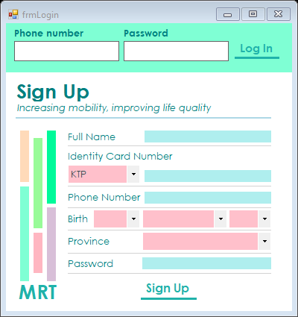

The image below is an example for new TICKETING MRT users

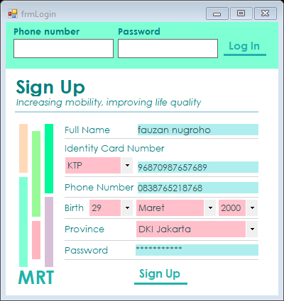

.

# MRT TICKETING

# ATTRIBUTES

The system will ensure that the data you fill in is correct, if it is not correct it can be canceled, or repeat it again

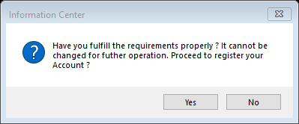

if it is correct the system will notify if it is successful

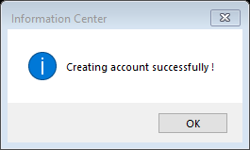

# MRT TICKETING (SS)

The picture below is a place to refill money or what is referred to as a top up, before buying a ticket, try first to fill in the funds that are in the ticketing

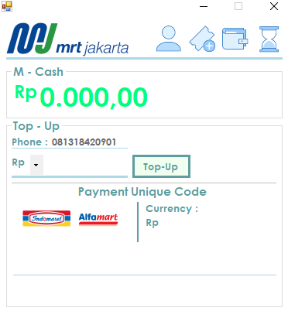

The image below is an example that has been topped up



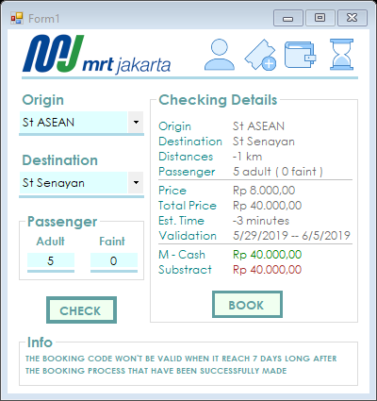

# MRT TICKETING (SS)

# MRT TICKETING (SS)

The image below is a form to fill your destination ticket on the form also displays various things such as: routes, distances, fees, arrivals, and more





The image below is an example form to fill your destination ticket on the form also displays various things such as: routes, distances, fees, arrivals, and more



The booking code below will come out if we press the booking button next to the check button



# MRT TICKETING (SS)

E

# MRT TICKETING (SS)

E

E

The image below is the history of the owner of the account



# CONFIGURATION

E

**Hardware:** Laptop compatible with an Intel Core Duo processor, 4-GB RAM

**Operating System:** Microsoft Windows 10

**Software:** Microsoft Visual Studio Community 2017

|  |  |  |
| --- | --- | --- |
|  |  | **PROJECT FILE DETAILS** |
| **No** | **File Name** | **Remarks** |
| 1 | Project 5.docx | Word Document Contain Relation |
| 2 | Login.cs | Document of Source Code In Ms. Visual Studio Community 2017 |
| 3 | Top Up.cs | Document of Source Code In Ms. Visual Studio Community 2017 |
| 4 | Booking.cs | Document of Source Code In Ms. Visual Studio Community 2017 |
| 5 | Profile.cs | Document of Source Code In Ms. Visual Studio Community 2017 |
| 6 | History.cs | Document of Source Code In Ms. Visual Studio Community 2017 |